# Uploading Case Documents

If you are a Microsoft employee who requires immigration support, you might receive an email from the Microsoft Global Migration team asking you to upload documents required for your case. When you receive such an email (see example in Figure 1), follow the instructions in this document to access the **Instructions From Microsoft** page (see example in Figure 2) and to upload the required documents.

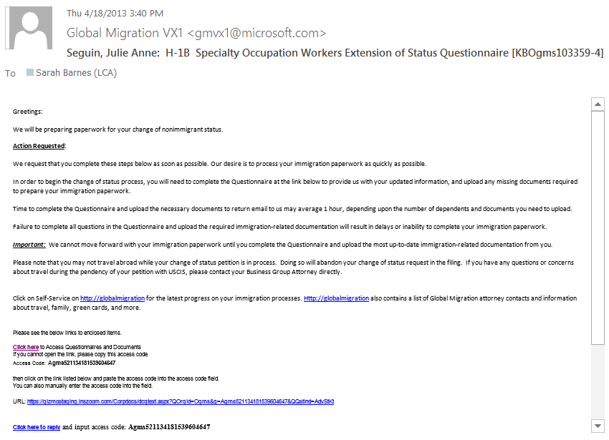

Figure 1

The **Instructions From Microsoft** page (Figure 2) might also contain a request to complete a questionnaire. See “Completing a Questionnaire” for instructions on completing the questionnaire.

Access the document upload utility by clicking **Click here** in the email (highlighted in Figure 1). If the link does not work, complete the following steps:

1. Copy the access code from the email (highlighted in Figure 1).
2. Click the URL link (highlighted in Figure 1).
3. In the dialog box that appears, paste the access code in the text box and click **OK**.

In the **Instructions From Microsoft** page that appears, the **Case Docs Check List** (highlighted in Figure 2) contains a list of the documents required for your case.

*Figure 2*

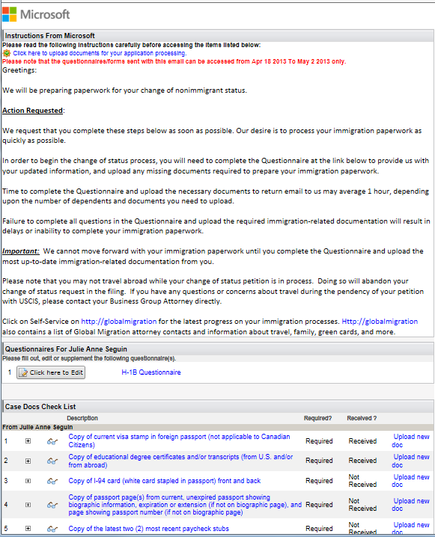

**Note** The **Required?** column of the **Case Docs Check List** may indicate some documents as **If Applicable**. Please be sure to upload any “If Applicable” documents that apply to your case. The Global Migration team may not be able to proceed with your case if all necessary documents are not uploaded.

If necessary, scroll down to view the complete list.

## Uploading Documents

For each document that you want to upload, perform the following steps:

1. From the **Case Docs Check List**, copy (to your clipboard) the description of the document that you want to upload (highlighted in Figure 3). You will paste this description in a later step.
2. Click **Upload new doc** for that document (highlighted in Figure 3).

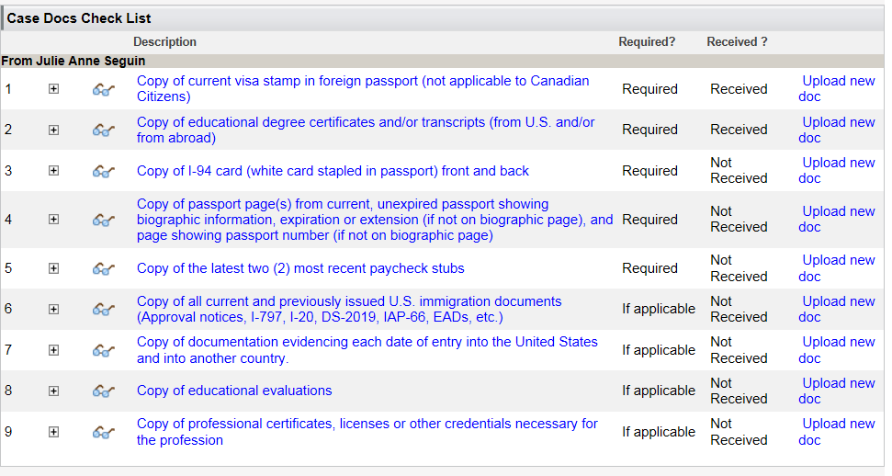

Figure 3

1. In the **Digital Documents List** dialog box that appears, click **Upload New Doc** (highlighted in Figure 4).

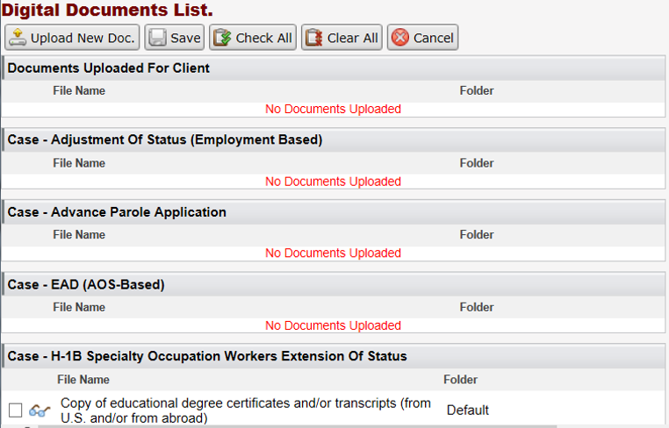

Figure 4

1. In the **Upload Documents** dialog box that appears, complete the following steps:
   1. In the description field, paste the description you copied (highlighted in Figure 5).
   2. Click **Browse** (highlighted in Figure 5). In the **Choose File to Upload** dialog box that appears, navigate to the file you want to upload, select it, and then click **Open**.

The **Choose File to Upload** dialog box should close. In the **Upload Documents** dialog box, the **File Name** field should now contain the path and file name of the file you selected.

* 1. Click **Upload File** (highlighted in Figure 5).

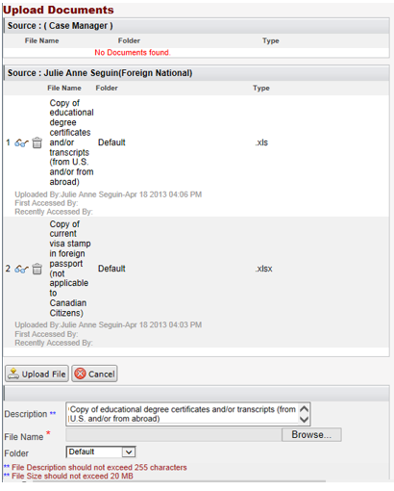

Figure 5

The **Upload Documents** dialog box should close.

1. In the **Case Docs Check List**, find the document you chose to upload in the previous step and click **Upload new doc** for that document.
2. In the **Digital Documents List** dialog box that opens, find the name of the file you chose to upload, select it, and then click **Save** (highlighted in Figure 6).

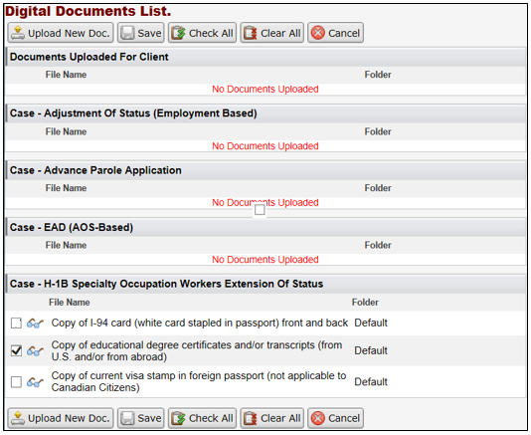

Figure 6

In the **Case Docs Check List**, in the row for the file you chose to upload, in the **Received?** column, you should see the status **Received** (highlighted in Figure 7).

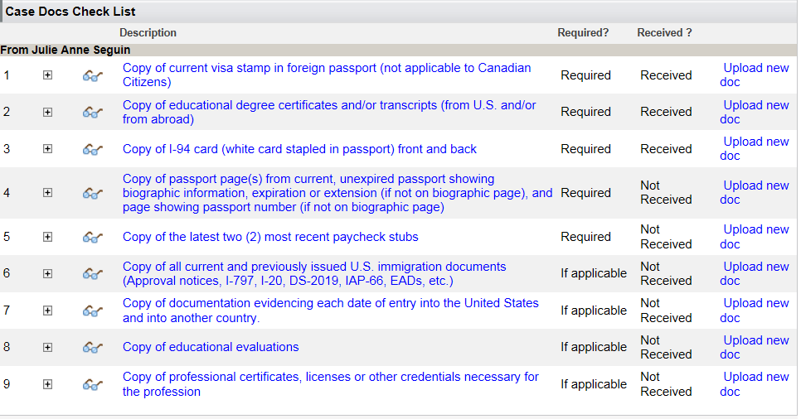

Figure 7

1. If the **Instructions From Microsoft** page includes a request to complete a questionnaire, complete the questionnaire following the instructions “Completing a Questionnaire,” and then proceed to the next section, “Informing Microsoft.”

If the **Instructions From Microsoft** page does not include a request to complete a questionnaire, click **Close** at the bottom of the page (highlighted in Figure 8) and do not proceed to the next section, “Informing Microsoft.”

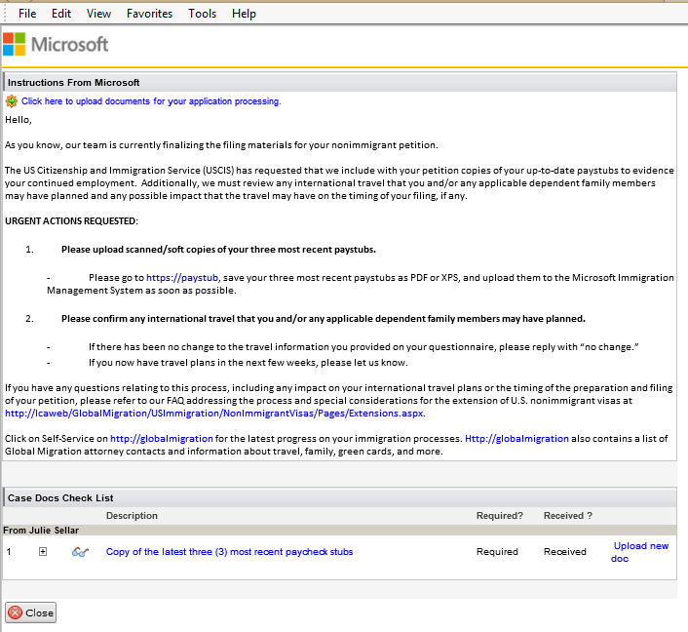

Figure 8

## Informing Microsoft

This section only applies when the **Instructions From Microsoft** page includes a request to complete a questionnaire along with a request to upload case documents.

When you have completed all of the instructions in the **Instructions From Microsoft** page, follow this procedure to inform Microsoft:

1. At the bottom of the **Instructions From Microsoft** page, below the **Case Docs Check List**, click **Inform Microsoft** (highlighted in Figure 9).

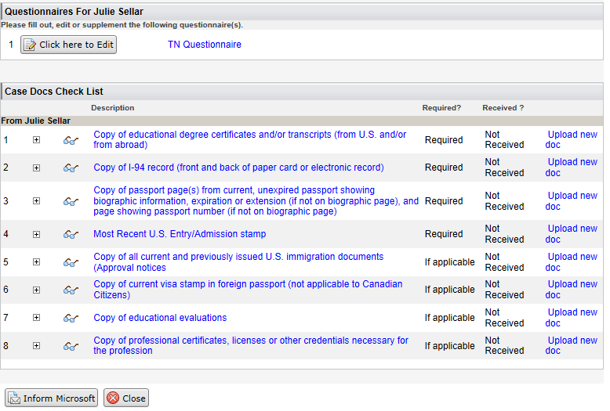

Figure 9

**Important** Read the warning in the message that appears and be sure that all of the information is accurate. You will not have access to edit or update your questionnaire after you submit it.

1. If you are satisfied that all of the information is accurate, click **OK** in the warning message box. Otherwise, click **Cancel**.
2. In the **Send Email** dialog box that appears, check that the **From** email address is a correct email address for you and make any additions to the email that you believe are necessary. If you do not have any questions for the email recipient, you do not need to make any edits to the email.

**Important** Do not change the **To** email address or the **Subject** text.